In the KiritoAsuna Bank, there is a special queue designed for registering to the bank. Customers are regularly queued by their time of arrival. However, there are some exceptions: Silver, Gold, And Platinum. Here is how the queuing system works:

Priority 1: Platinum. If there are more than one Platinum, Platinum are ordered by their arrival time to the queue.

Priority 2: Gold. If there are more than one Gold, Gold are ordered by their arrival time to the queue.

Priority 3: Silver. If there are more than one Silver, Silver are ordered by their arrival time to the queue.

Priority 4: Regular Passengers. If there are more than one passengers, they are ordered by their arrival time to the queue.

Create a program with the following description:

1. Main menu displaying current passengers in queue, including: **name, age, and status (Regular/Silver/Gold/Platinum)**. Show also the **maximum and minimum age** of the passengers and the **total passengers count** in the queue.
2. Menu 1 for entering a new passenger to the queue. Accept the following data: **name, age, status (Regular, Silver, Gold or Platinum)**.
3. Menu 2 for dequeuing a Customers. Display the dequeued Customers **name**.

Menu 3 for exiting the program.

**Tampilan Awal :**

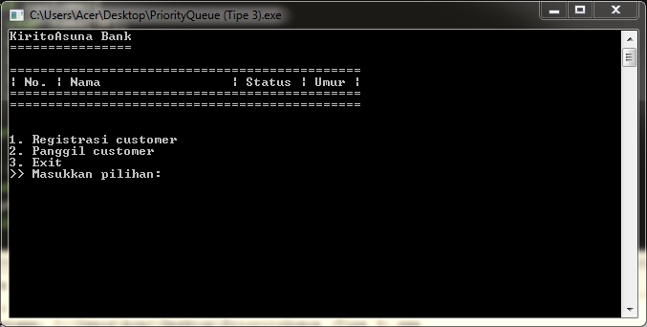

**JIka Memilih Menu 1, Maka Tampilannya :**

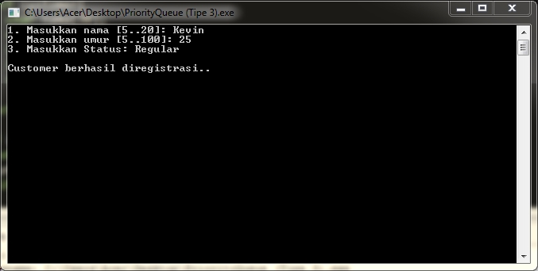

**Tampilan ketika banyak data sudah diinput :**

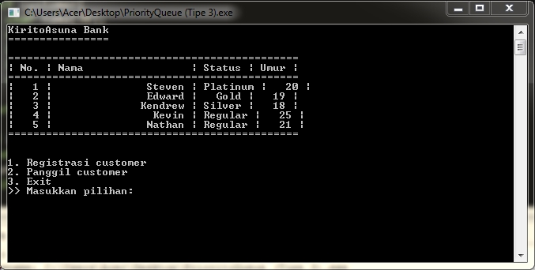

**Ketika Memilih Menu 2, maka Hapus data paling awal , menjadi :**

